COPE Consortium IRB Tool Kit

We have compiled a document to assist you as you are trying to get approval for use of the COVID-19 Symptom Study app at your institution. These documents are templates to help you as you work towards getting IRB approval, but please acknowledge that local requirements might be different from our Partners IRB. Please also understand that our ability to change documents within the app are limited, which include our terms of use, consent forms, and privacy policy. Our questionnaire was designed to be brief, but comprehensive and adaptable to rapid developments associated with COVID-19. We understand you may have individual research questions of interest. We are happy to take suggestions (e-mail predict@mgh.harvard.edu) but we may not be able to accommodate all requests.

Table of Contents
1 IRB Approval Letter 2
2 COVID-19 Symptom Study App Screenshots 5
3 Questionnaire 8
4 Recruitment Letters 21
5 Terms of Use 24
6 Privacy Policy 29
7 Consent Process 36

Partners Human Research Partners HealthCare
399 Revolution Drive, Suite 710
Somerville, MA 02145 Tel:857-282-1900 Fax:857-282-5693
Notification of IRB Review

Protocol #: 2020P000909
April 01, 2020
Date:

To:

From:

Title of Protocol:

Chan, Andrew, MD,MPH MGH
Partners > MGH > Medical Services > Clinical & Translational Epidemiology Unit
Partners Human Research
399 Revolution Drive, Suite 710 Somerville, MA 02145
COVID-19 Real-time Symptoms Epidemiology Tracker--CORSET Study

Version/Number: 1
Version Date:
3/23/2020 IRB Amendment #: 2
IRB Review Type: Expedited IRB Approval Date:
04/01/2020
Approval/Activatio
04/01/2020
n Date:
Institutional Review
Next Review:
IRB Expiration Date: 03/27/2021

This project has been reviewed and approved by the PHS IRB. During the review of this project, the IRB specifically considered (i) the risks and anticipated benefits, if any, to subjects; (ii) the selection of subjects; (iii) the procedures for obtaining and documenting informed consent; (iv) the safety of subjects; and (v) the privacy of subjects and confidentiality of the data.

Please note that if an IRB member had a conflict of interest with regard to the review of this project, consistent with IRB policies and procedures, the member was required to recuse him/herself and, if applicable, leave the room during the discussion and vote on this project except to provide information requested by the IRB.

Partners has implemented the Policy on Conduct of Human Research Activities during COVID-19 Operations. All research must comply with restrictions and requirements outlined in this policy. Principal Investigators and research team must review and follow all restrictions related to recruitment and study activities.

The following documents were reviewed and approved by the IRB:

Official Version Generated from the Partners Human Research System 04/01/2020 15:13

Partners Human Research Partners HealthCare
399 Revolution Drive, Suite 710 Somerville, MA 02145
Tel:857-282-1900 Fax:857-282-5693

Consent Form
Consent Form/ Information Sheet
Advertisement

- Updated the app's privacy policy.
- Modified the recruitment letter sent to Nurses' cohort study.
- Added a follow-up email as a reminder for individuals.

As Principal Investigator, you are responsible for ensuring that this project is conducted in compliance with all applicable federal, state and local laws and regulations, institutional policies, and requirements of the IRB, which include, but are not limited to, the following:

1. Submission of any and all proposed changes to this project (e.g., protocol, recruitment materials, consent form, status of the study, etc.) to the IRB for review and approval prior to initiation of the change(s), except where necessary to eliminate apparent immediate hazards to the subject(s). Changes made to eliminate apparent immediate hazards to subjects must be reported to the IRB as an unanticipated problem.
2. Submission of a continuing review submission or institutional status report as required by the IRB and/or institution to continue the research, and submission of a final report when the project has been closed or completed.
3. Submission of any and all unanticipated problems, including adverse event(s) in accordance with the IRB's policy on reporting unanticipated problems including adverse events.
4. Obtaining informed consent from subjects or their legally authorized representative prior to initiation of research procedures when and as required by the IRB and, when applicable, documenting informed consent current IRB approved consent form(s) with the IRB-approval stamp in the document footer.
5. Informing all investigators and study staff listed on the project of changes and unanticipated problems, including adverse events, involving risks to subjects or others.
6. When investigator financial disclosure forms are required, submitting updated financial disclosure forms for yourself and for informing all site responsible investigators, co- investigators and any other members of the study staff identified by you as being responsible for the design, conduct, or reporting of this research study of their obligation to submit updated Investigator Financial Disclosure Forms for this protocol to the IRB if
(a)they have acquired new financial interests related to the study and/or (b) any of their previously reported financial interests related to the study have changed.

IMPORTANT REMINDER: THE IRB HAS THE AUTHORITY TO TERMINATE PROJECTS
THAT ARE NOT IN COMPLIANCE WITH THESE REQUIREMENTS.

Questions related to this project may be directed to Line Papin | Tel: 857-282 - 1908 | Email: lpapin@partners.org

cc:

Official Version Generated from the Partners Human Research System 04/01/2020 15:13

Partners Human Research Partners HealthCare
399 Revolution Drive, Suite 710 Somerville, MA 02145
Tel:857- 282-1900 Fax:857-282-5693

Andrew Chan, MD, MPH, Principal Investigator, Clinical & Translational Epidemiology Unit, Medical Services

Marina Magicheva-Gupta, Research Coordinator/Manager, Other

Official Version Generated from the Partners Human Research System 04/01/2020 15:13
COVID-19 Symptom Study App Screenshots
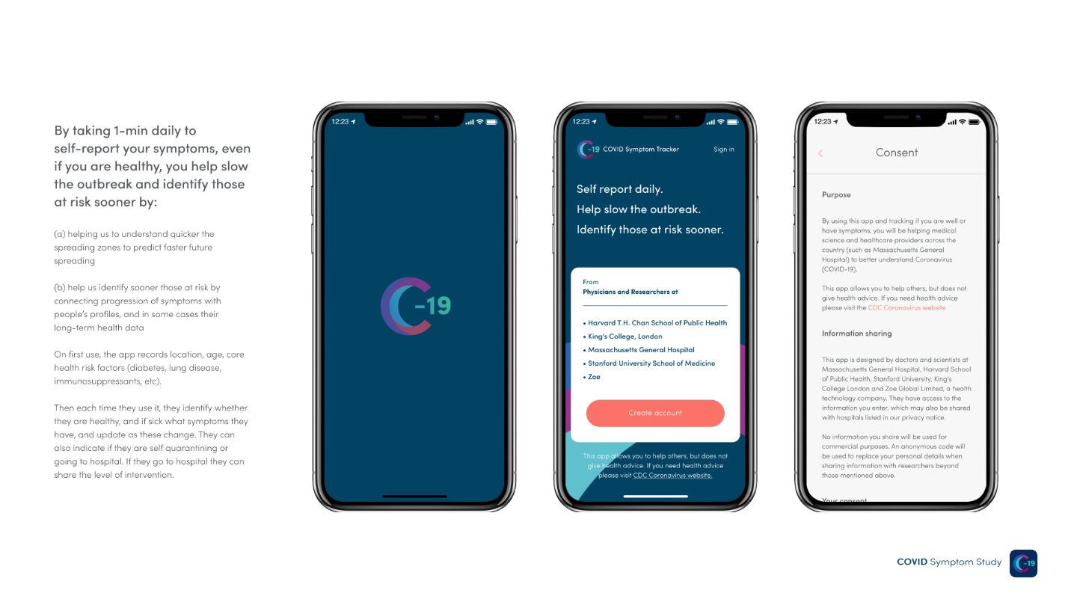
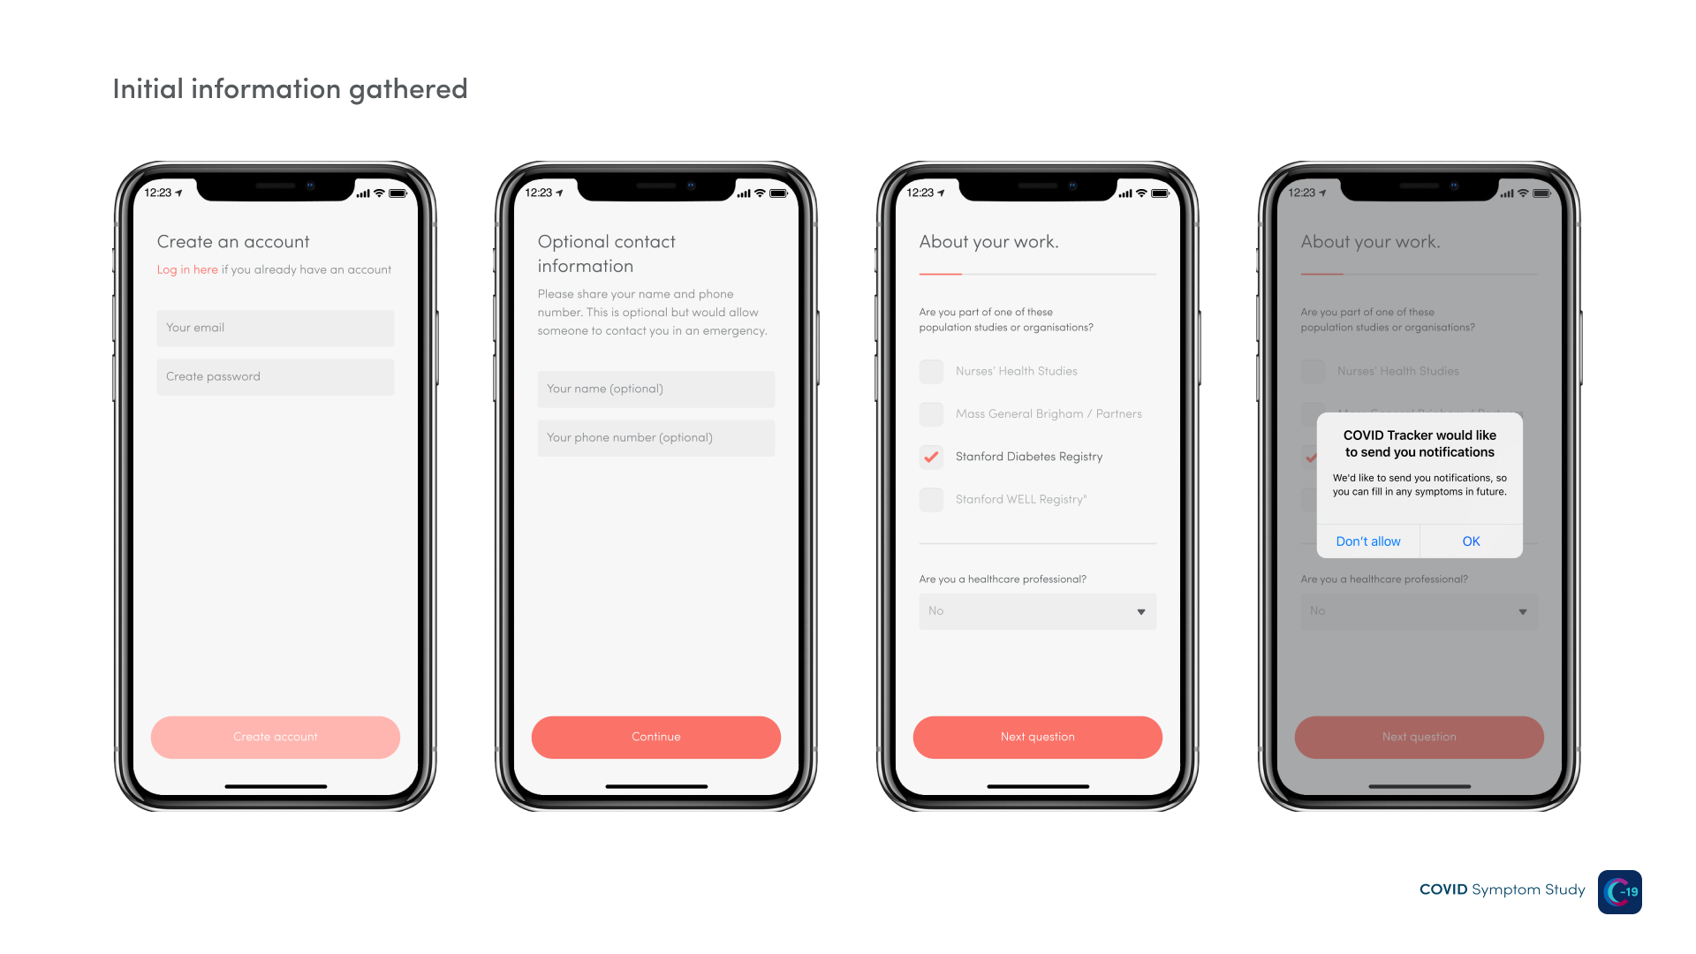
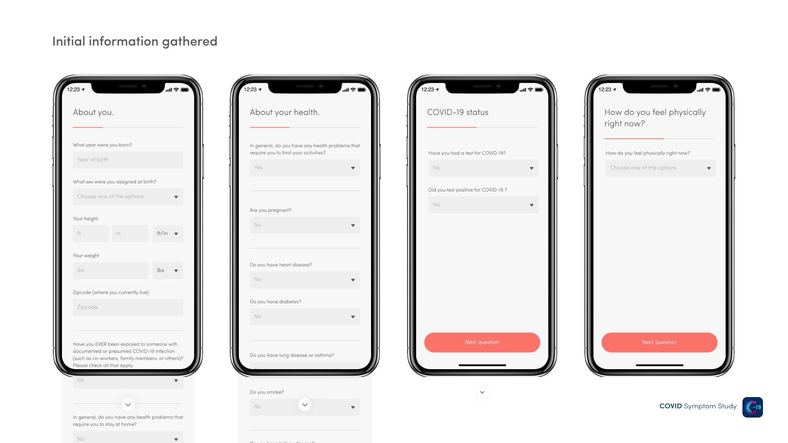
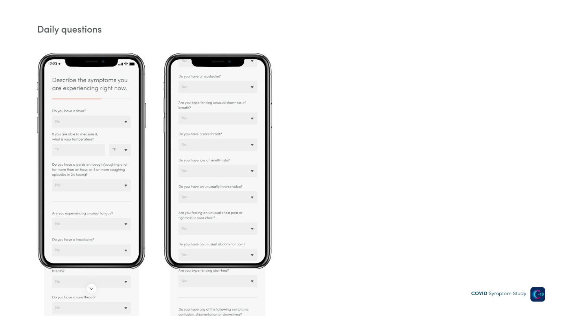
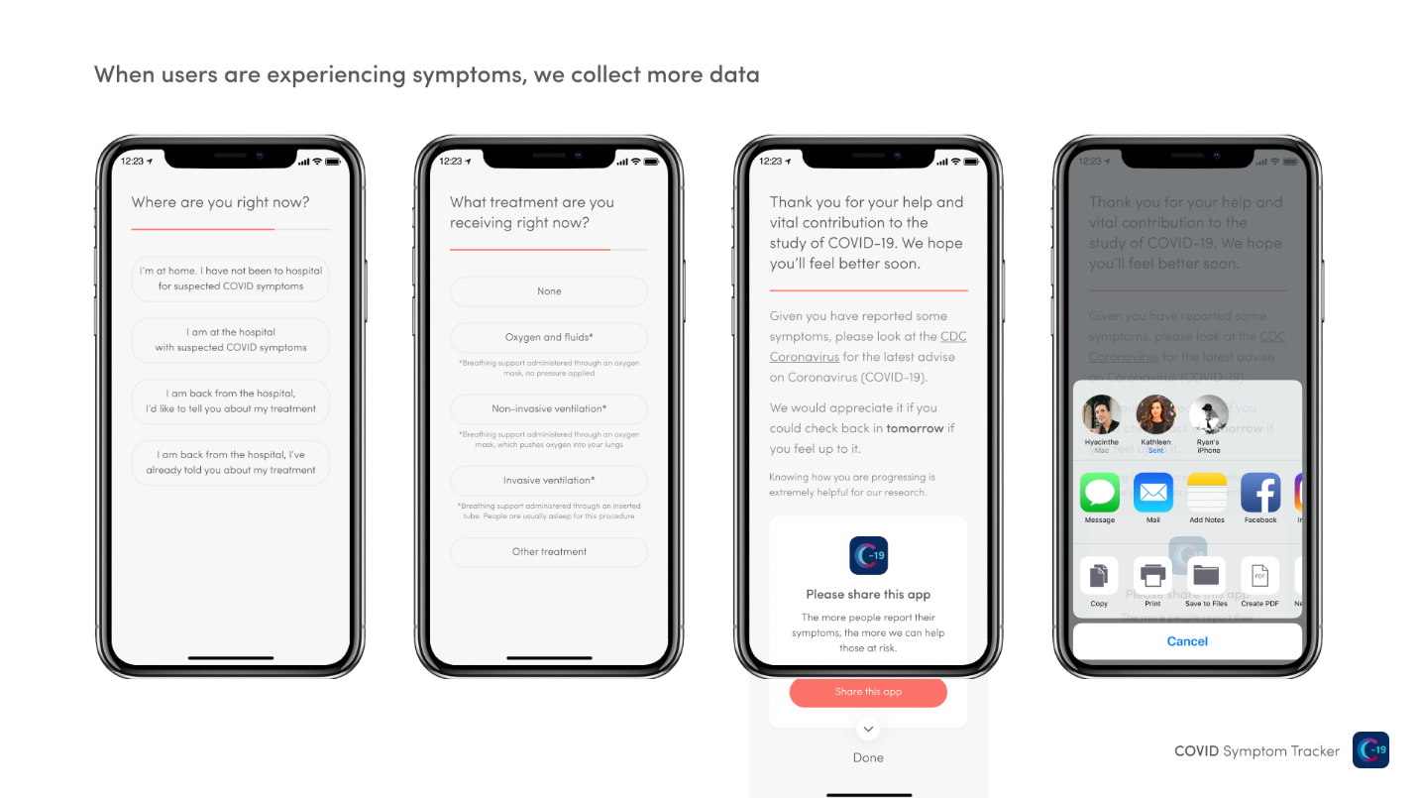

COVID Symptom Tracker

List of question

Q (single-select): I am in an existing research study or trial, and I want my data to be shared with investigators on that study.
1. Yes, I am
2. No, I am not

Q (text entry): Your email
Q (text entry): Your name
Q (text entry): Phone number
If "Yes, I am" show:
Q (multi-select): Is your study one of the following?
- Harvard Nurses’ Health Studies
- Harvard Growing Up Today Study
- Harvard Health Professionals Follow-Up Study
- Mass General/ Brigham
- Stanford Nutrition Studies Group
- Multiethnic Cohort Study
- PREDICT 2
- American Cancer Society Cancer Prevention Study-3
- UCSD/COH California Teachers Study
- The Sister Study
- The Agricultural Health Study (AHS)
- The GuLF Study
- ASPREE-XT
- Black Women’s Health Study
- ColoCare study
- PROMISE/PCROWD study
- PREDETERMINE study
- NIEHS Environmental Polymorphisms Study
- Chasing COVID-CUNY ISPH
- CovidNearYou/FluNearYou
- Partners Biobank
- Mass Eye and Ear Infirmary
- MD Anderson D3CODE Study
- Hispanic Colorectal Cancer Study
- Colon Cancer Family Registry
- Louisiana State University
- COVID SIREN
- NorthShore Genomic Health Initiative
- C19 Human Genomics Study

Q (text entry): If not, add the names of your studies.

Q (text entry): If you know it, what is the name of your contact at the study (investigator, physician, study coordinator, etc.)?

Q (text entry): If you know it, what university or hospital runs this study?

Q (text entry): What is the NCT number (if you know it)?

Q (select one): Are you a healthcare worker (including hospital, elderly care, or in the community):
1. No
2. Yes, I currently interact with patients
3. Yes, but I do not currently interact with patients

Q (select one): Do you care for multiple people in the community, with direct contact with your patients?
1. No
2. Yes

If "Yes, I currently interact with patients" show:
Q (multi-select): Since the COVID-19 epidemic began, have you physically worked in?
- Hospital inpatient
- Hospital outpatient
- Clinic outside a hospital
- Nursing home/ elderly care or group care facility
- Home health
- School clinic
- Other health care facility

Q (select one): Have you EVER interacted in person with patients with documented or suspected COVID-19 infection?
1. Yes, documented COVID-19 cases only
2. Yes, suspected COVID-19 cases only
3. Yes, both documented and suspected COVID-19 cases
4. Not that I know of

Q (select one): Since the COVID-19 epidemic began, have you used person protective equipment (PPE) at work?
1. Always
2. Sometimes
3. Never

If "Always" show:
Q (select one): Choose one of the options
1. I have had all the PPE I need for work
2. I had to reuse PPE because of shortage

If "Sometimes" show:
Q (select one): Choose one of the options
1. I haven’t always needed to use PPE, but have had enough when I did
2. I would have used PPE all the time, but I haven’t had enough
3. I’ve had to reuse PPE because of shortage

If “Never" show:
Q (select one): Choose one of the options
1. I haven’t needed PPE
2. I needed PPE, but it was not available

Q (text entry): What year were you born?

Q (select one): What sex were you assigned at birth?
1. Male
2. Female
3. Intersex
4. Prefer not to say

Q (select one): What gender do you most identify with?
1. Male
2. Female
3. Intersex
4. Prefer not to say
5. Other, please specify

If “Other, please specify" show:
Q (text entry): Please specify as you wish

Q (multi-select): What is your race?
- American Indian or Alaska Native
- Asian
- Black or African- American
- Native Hawaiian or other Pacific Islander
- White
- Other, please specify
- Prefer not to say

If “Other, please specify" show:
Q (text entry): Please specify your race

Q (select one): What is your ethnicity?
1. Hispanic or Latino or Spanish origin
2. Not Hispanic or Latino, or Spanish origin
3. Prefer not to say

Q (text entry): Your height?
Q (text entry): Your weight?
Q (text entry): Your zipcode?
Q (multi-select): Have you EVER been exposed to someone with documented or suspected COVID-19 infection (such as co-workers, family members, or others)? Please check all that apply.
- Yes, documented COVID-19 cases only
- Yes, suspected COVID-19 case only
- Yes, both documented and suspected COVID-19 cases
- Not that I know of
Q (select one): In general, do you have any health problems that require you to stay at home?
1. No
2. Yes
Q (select one): Do you need someone to help you on a regular basis?
1. No
2. Yes
Q (select one): If you need help, can you count on someone close to you?
1. No
2. Yes
Q (select one): Do you regularly use a cane, walker or wheelchair to get about?
1. No
2. Yes
Q (select one): In general, do you have any health problems that require you to limit your activities?
1. No
2. Yes
If answered "female" previously show:
Q (select one): Are you currently having periods?
1. I’ve never had periods
2. I’m currently having periods
3. I’ve stopped having periods
4. I’m pregnant
5. I’m not currently having periods
6. Prefer not to say
7. Other

If currently having periods,
Q (select one): Do you periods usually occur?
1. regularly every 3-6 weeks
2. Regularly, but less often than every 6 weeks
3. At irregular intervals

If I’ve stopped having periods
Q (text response): At what age did your periods stop?
If pregnant,
Q (text response): How many weeks pregnant are you?
Q (select one): Are you taking any of the following forms of hormone treatment?
1. No
2.Combined oral contraceptive pill
3. Progesterone only pill
4. Mirena or other hormone coil
5. Depot injection or implant
6. Hormone replacement therapy
7. Estrogen hormone therapy for gender transitioning
8. Testosterone hormone therapy
9. Prefer not to say
10. Other

Q (select one): Do you have heart disease?
1. No
2. Yes
Q (select one): Do you have diabetes?
1. No
2. Yes
Q (select one): Do you have hayfever (seasonal allergies)?
1. No
2. Yes

Q (select one): Do you have eczema?
1. No
2. Yes

Q (select one): Do you have asthma?
1. No
2. Yes
Q (select one): Do you have lung disease?
1. No
2. Yes

Q (select one): Do you smoke?
1. Never
2. Not currently
3. Yes
If "Not currently " show:
Q (text entry): How many years since you last smoked?
Q (select one): Do you have kidney disease?
1. No
2. Yes
Q (select one): Are you living with cancer?
1. No
2. Yes
If "Yes" show:
Q (text entry): What type of cancer do you have?
Q (select one): Are you on chemotherapy or immunotherapy for cancer?
1. No
2. Yes
Q (select one): Do you regularly take immunosuppressant medications (including steroids, methotrexate, biologic agents)?
1. No
2. Yes
Q (select one): Do you regularly take aspirin (baby aspirin or standard dose)?
1. No
2. Yes
Q (select one): Do you regularly take “NSAIDs” like ibuprofen, nurofen, diclofenac, naproxen?
1. No
2. Yes
Q (select one): Are you regularly taking any blood pressure medications?
1. No
2. Yes
If "Yes" show:
Q (select one): Are you regularly taking any blood pressure medications ending in “-pril”, such as enalapril, lisinopril, captopril, ramipril?
1. No
2. Yes
Q (select one): Are you regularly taking blood pressure medications ending in “-sartan”, such as losartan, valsartan, irbesartan?
1. No
2. Yes
Q (multi-select): Have you been taking any vitamins or other supplements regularly for more than 3 months? Regularly means more than 3 times a week on average. Select all that apply. We are exploring the possible effects of vitamin supplements on COVID infection.
- No
- Vitamin C
- Vitamin D
- Omega-3 or Fish Oil
- Zinc
- Garlic
- Probiotics
- Multi-vitamins and minerals
- Other, please specify
- Prefer not to say

If “Other” show:

Q (text entry): Please specify the vitamins or supplements.

Q (select one): If you know it, what is your blood group?
1. A
2. B
3. AB
4. O
5. I don’t know my blood group for certain
6. Prefer not to say

The following questions on weight, nutrition, and exercise are to help us understand whether COVID may be impacting our health in these areas and how significant these effects are. These questions are all optional. Since March when COVID became prevalent:

Q (select one): How has your weight changed?
1. Increased
2. Decreased
3. Stayed the same
4. Prefer not to say

If "Increased" or “Decreased” show:
Q (text entry): By how much (an estimate is fine)?
Q (select one): How has your diet changed in your opinion?
1. It has become healthier
2. It has become more unhealthy
3. It has stayed the same
4. Prefer not to say

Q (select one): How has your snacking changed?
1. I am snacking more
2. I am snacking less
3. My snacking levels are the same
4. Prefer not to say

Q (select one): How has your alcohol consumption changed?
1. I am drinking more alcohol
2. I am drinking less alcohol
3. I don’t drink alcohol
4. My alcohol consumption is the same
5. Prefer not to say

Q (select one): Have your physical activity levels changed?
1. Yes, increased
2, Yes, decreased
3. No change, has remained the same
4. Prefer not to say

Q: New COVID studies and how you can help. Are you interested in being contacted to learn about additional studies related to COVID-19 or use of this app?
Q (select one): Have you felt unwell in the month before you started reporting on this app?
1. No
2. Yes

If "Yes" show:
Q (multi-select): Did you have any of the following symptoms?
- Loss of smell/taste
- Unusual shortness of breath
- Unusual fatigue
- Fever
- Skipped meals
- Persistent cough
- Diarrhea
- Unusual chest pain or tightness in your chest
- Hoarse voice
- Abdominal pain
- Confusion, disorientation, drowsiness

Q (text entry): How many days ago did your symptoms start?
Q (select one): Are you still experiencing symptoms?
1. No
2. Yes

If "Yes" show:
Q (select one): How have your symptoms changed over the last few days?
1. Much better
2. A little better
3. The same
4. A little worse
5. Much worse

Q (select one): Do you think you have already had COVID-19, but were not tested?
1. No
2. Yes

If "Yes" show:
Q (select one): Did you have the classic symptoms (high fever and persistent cough) for several days?
1. No
2. Yes

This information can help us understand the impact of social distancing and face masks on infection rates. These questions are completely optional.

Q (select one): How much have you been isolating over the last week?
Q (text response): In the last week how many times have you been outside, with little interaction with people outside your household (e.g. exercise)?
Q (text response): In the last week, how many times have you visited somewhere with lots of people (e.g. groceries, public transport, work)?
Q (text response): In the last week how many times have you visited a healthcare setting, including your work(e.g. hospital, clinic, dentist, pharmacy)?
Q (select one): In the last week, did you wear a face mask when outside the house?
1. Never
2. Sometimes
3. Most of the time
4. Always
5. Not applicable

If “Sometimes”, “Most of the Time”, or “Always” show:

Q (multi-select): What kind of face mask do you use? Check all that apply.
a. Cloth or scarf
b. Surgical mask
c. N95/FFP respirator
d. Not sure/ prefer not to say
e. Other, please specify:

If “Other”, long text entry appears

Q (select one): If you have ever had a COVID-19 test, please add below. You can edit these at any time in the future.
1. Add new test
2. I have never had a COVID test

If adding a test,

Q (select one): Do you know the date of your test?
1. No
2. Yes

If no,

Q (select one): Between which two dates do you think you had your test?

Select dates on a calendar

If yes
Q. When was your test?
Q (select one): How was this test performed?
1. A swab of my nose or throat
2. I spat in a cup/ tube
3. A finger-prick blood test
4. A blood test, done using a needle
5.. Other, please specify

If “A swab of my nose or throat”:

Q (select one): Did a trained worker swab you?
1. Yes
2. No
3. Unsure

If other, please indicate how the test was performed.

Q (select one): Where was your test performed?
1. At home
2. Hospital (not drive-through)
3. Work (excluding hospital or GP)
4. Local health department
5. Store or pharmacy clinic
6. Other, please specify

If other, please specify the test location

Q (select one): What are the results of this test?
1. Negative
2. Positive
3. Not clear/ failed
4. Waiting for results

Q (select one): How do you feel physically right now?
1. I feel physically normal
2. I’m not feeling quite right
If "I’m not feeling quite right" show:
Q (select one): Do you have a fever or feel too hot?
1. No
2. Yes

Q (select one): Do you feel chills or shivers (feel too cold)?
1. No
2. Yes

Q (number entry): If you are able to measure it, what is your temperature?
Q (select one): Do you have a persistent cough (coughing a lot for more than an hour, or 3 or more coughing episodes in 24 hours)?
1. No
2.Yes
Q (select one): Are you experiencing unusual fatigue?
1. No
2. Mild fatigue
3. Severe fatigue - I struggle to get out of bed
Q (select one): Do you have a headache?
1. No
2. Yes
If yes,
Q (select one): How often are you experiencing headaches?
1. All of the day
2. Most of the day
3. Some of the day

Q (select one): Have you felt nausea or experiencing vomiting?
1. No
2. Yes

Q (select one): Are you experiencing dizziness or light-headedness?
1. No
2. Yes

Q (select one): Are you experiencing unusual shortness of breath or have trouble breathing?
1. No
2. Yes. Mild symptoms - slight shortness of breath during ordinary activity.
3. Yes. Significant symptoms - breathing is comfortable only at rest.
4. Yes. Severe symptoms - breathing is difficult even at rest.
Q (select one): Do you have a sore or painful throat?
1.No
2.Yes
Q (select one): Do you have loss of smell/taste?
1. No
2. Yes
Q (select one): Do you have an unusually hoarse voice?
1. No
2.Yes
Q (select one): Are you feeling unusual chest pain or tightness in your chest?
1.No
2.Yes
Q (select one): Do you have unusual abdominal pain or stomach ache?
1.No
2.Yes
Q (select one): Are you experiencing diarrhea?
1.No
2.Yes
If yes, Q (select one): How many loose stools in the last 24 hours?
1. 1-2
2. 3-4
3. 5+

Q (select one): Do you have unusual strong muscle pains or aches?
1. No
2. Yes

Q (select one): Have you had raised, red, itchy, welts on the skin or sudden swelling of the face or lips?
1. No
2. Yes

Q (select one): Have you had any red/purple sores or blisters on your feet, including your toes?
1. No
2. Yes

Q (select one): Do you have any of the following symptoms: confusion, disorientation, or drowsiness?
1. No
2. Yes

Q (select one): Do your eyes have any unusual eye-soreness or discomfort (e.g. light sensitivity, excessive tears, or pink/red eye)?
1. No
2. Yes

Q (select one): Have you been skipping meals?
1. No
2. Yes
Q (long text entry): Any there other important symptoms you want to share with us?
Q (select one): Where are you right now?
1. I’m at home. I have not been to the clinic or hospital for suspected COVID symptoms
2. I am at the clinic or hospital with suspected COVID symptoms
3. I am back from the clinic or hospital, I’d like to tell you about my treatment
4. I am back from the clinic or hospital, I’ve already told you about my treatment

If "I am in the hospital with suspected COVID symptoms" OR "I am back from the hospital, I’d like to tell you about my treatment" show:
Q (select one): What treatment are you (did you) receiving right now?
1. None
2. Oxygen and fluids* (*Breathing support through an oxygen mask, no pressure applied)
3. Non-invasive ventilation* (*Breathing support through an oxygen mask, which pushes oxygen into your lungs)
4. Invasive ventilation* (*Breathing support through an inserted tube. People are usually asleep for this procedure)
5. Other

If "Other" show:
Q (text): What medical treatment are you receiving?
Additional daily questions for healthcare workers, who currently treats patients shown on repeat use.
Q (select one): In the last day, have you interacted with any patients in person?
1. No
2. Yes

If yes,
Q (select one): In the last day, did you treat patients in person with documented or presumed COVID-19 infection? Please check all that apply.
1. Yes, documented COVID-19 cases only
2. Yes, suspected COVID-19 cases only
3. Yes, both documented and suspected COVID-19 cases
4. Not that I know of

Q (select one): In the last day, did you use personal protective equipment (PPE) at work? *Depending on your specific work requirements, PPE might include gloves, masks, face shields, etc.
1. Always
2. Sometimes
3. Never

If "Always" show:
Q (select one): Choose one of the options:
1. I had all the PPE I need for work
2. I had to reuse PPE because of a shortage

If "Sometimes" show:
Q (select one): Choose one of the options:
1. I haven’t always needed to use PPE all the time, but had enough when I did
2. I would have used PPE all the time, but I haven’t had enough
3. I’ve had to reuse PPE because of a shortage

If "Never " show:
Q (select one): Choose one of the options:
1. I haven’t needed PPE
2. I needed PPE, but it was not available

Additional question about participation in future research studies

Q. (select one): Are you interested in being contacted to learn about additional studies related to COVID-19 or use of this app?

1. Yes
2. No

Dear Colleague,

As dedicated participants in the Nurses’ Health Study II, sharing your experiences during this unprecedented COVID-19 pandemic can help inform the impact the disease is having on current and former nurses. As you may have heard, it has been challenging to track rates of infection. We would like to invite you to help address this challenge by taking 1-3 minutes/day to log your daily health status on a new COVID-19 symptom study that we have developed in collaboration with physicians and epidemiologists at King’s College and software engineers at Zoe, a health data science company. After initially downloading an app on your Apple or Android phone and providing some basic descriptive facts, the daily task is simply to note if you are feeling well or experiencing any symptoms. If you are still active in patient care, you’ll be asked about your use of gowns, gloves, and face shields. That’s all.

We encourage you to share your symptoms and health status daily, even if you feel well.

This project will offer real time data into the hidden iceberg of potential cases of COVID-19 in our communities and the full course of exposure, diagnosis, treatment and recovery. This information can be turned around rapidly to be used to guide public health planning around testing, quarantine, treatment, and recovery, which may have an immediate impact on our clinical response to this fast-moving pandemic.

To participate, please click the appropriate link below on your smartphone to download the app:

For Apple: https://apps.apple.com/us/app/covid-symptom-tracker/id1503529611?ls=1

For Android/Google: https://play.google.com/store/apps/details?id=com.joinzoe.covid_zoe

When signing up on the app, we ask that you use the same e-mail address that you use to connect with us. In addition, although optional, we’d greatly appreciate if you would complete all requested personal information as it will allow us to better link your information in the app back with your other data.

We will not be providing any of your previously collected personal information to our partners. However, they may use aggregated de-identified information along with data collected from others for studies such as mapping disease incidence. They will return your data to us so that we can link it with the information on diet and lifestyle you have already provided over the years. In the coming days, we may also contact you to join an optional web-based study to collect more detailed information about your experiences during the pandemic. Together, these will provide a unique opportunity to learn about the role of lifestyle, diet, and other factors on COVID-19 disease.

We know this is a very stressful and busy time, and we do not want to compound circumstances. However, we hope that you will be willing to join us in this unique opportunity to contribute to our health care community’s response to this unprecedented threat to our health professional colleagues and greater communities. For this research, we are interested in information from everyone, whether you are or are not currently working in the medical field.

Your friends and family, even if they are not health professionals, can also download the app and participate. The more people that use the app, the more helpful it will be!

We thank you for your continued dedication to the Nurses’ Health Studies. In the coming days, we will also contact you to join an optional web-based study to collect more detailed information LESS FREQUENTLY about your experiences during the pandemic.

Sincerely yours,
A. Heather Eliassen, ScD Walter C. Willett, MD ScD
Principal Investigator Principal Investigator

[Date]

Dear Colleague,

Thank you for participating in our research using the COVID Symptom Study app. If you have not already, please take a minute to track your symptoms daily through the app, even if you feel well. If you have not yet downloaded the app, please do so at the following links.

Apple Store for IPhone:

https://apps.apple.com/us/app/covid-symptom-tracker/id1503529611?ls=1

Play Store for Android:

https://play.google.com/store/apps/details?id=com.joinzoe.covid_zoe

We thank you for your continued dedication to the Nurses’ Health Studies.
Sincerely yours,
A. Heather Eliassen, ScD Walter C. Willett, MD ScD
Principal Investigator Principal Investigator

Terms of Use
Effective date: March 27, 2020
Welcome to the COVID-19 Symptom Tracker, provided by Zoe Global Limited (together with its affiliates, “Zoe,” “us,” “we”). Please read on to learn the rules and restrictions that govern your use of our website(s), products, services and applications (the “Services”). By using this app and tracking if you are well or have symptoms, you will be helping medical science and healthcare providers across the country (such as Massachusetts General Hospital) to better understand Coronavirus (COVID-19). The Services are not intended for commercial purposes. If you have any questions, comments, or concerns regarding these terms or the Services, please contact us at:
For queries please email covidtrackingquestionsus@joinzoe.com and to leave leavecovidtracking@joinzoe.com
Address: Zoe Global Limited, 164 Westminster Bridge Road, London SE1 7RW, United Kingdom
These Terms of Use (the “Terms”) are a binding contract between you and us. Your use of the Services in any way means that you agree to all of these Terms, and these Terms will remain in effect while you use the Services. These Terms include the provisions in this document as well as those in our Privacy Policy [INSERT LINK TO PRIVACY POLICY].
Please read these Terms carefully. They cover important information about Services provided to you. These Terms include information about future changes to these Terms, limitations of liability, a class action waiver and resolution of disputes by arbitration instead of in court. PLEASE NOTE THAT YOUR USE OF AND ACCESS TO OUR SERVICES ARE SUBJECT TO THE FOLLOWING TERMS; IF YOU DO NOT AGREE TO ALL OF THE FOLLOWING, YOU MAY NOT USE OR ACCESS THE SERVICES IN ANY MANNER.
ARBITRATION NOTICE AND CLASS ACTION WAIVER: EXCEPT FOR CERTAIN TYPES OF DISPUTES DESCRIBED IN THE ARBITRATION AGREEMENT SECTION BELOW, YOU AGREE THAT DISPUTES BETWEEN YOU AND US WILL BE RESOLVED BY BINDING, INDIVIDUAL ARBITRATION AND YOU WAIVE YOUR RIGHT TO PARTICIPATE IN A CLASS ACTION LAWSUIT OR CLASS-WIDE ARBITRATION.

Will these Terms ever change?
We are constantly trying to improve our Services, so these Terms may need to change along with our Services. We reserve the right to change the Terms at any time, but if we do, we will place a notice on our site located at https://covid.joinzoe.com/us, post a notice within the app, send you an email, and/or notify you by some other means.
If you don’t agree with the new Terms, you are free to reject them; unfortunately, that means you will no longer be able to use the Services. If you use the Services in any way after a change to the Terms is effective, that means you agree to all of the changes.
Except for changes by us as described here, no other amendment or modification of these Terms will be effective unless in writing and signed by both you and us.

What about my privacy?
Zoe takes the privacy of its users very seriously. For the current Zoe Privacy Policy, please click here.

What are the basics of using Zoe?
You may be required to sign up for an account using your email. You represent and warrant that you are an individual of legal age to form a binding contract (or if not, you’ve received your parent’s or guardian’s permission to use the Services and have gotten your parent or guardian to agree to these Terms on your behalf). If you’re agreeing to these Terms on behalf of an organization or entity, you represent and warrant that you are authorized to agree to these Terms on that organization’s or entity’s behalf and bind them to these Terms (in which case, the references to “you” and “your” in these Terms, except for in this sentence, refer to that organization or entity).
You will only use the Services for your own internal, personal, non-commercial use, and not on behalf of or for the benefit of any third party, and only in a manner that complies with all laws that apply to you. If your use of the Services is prohibited by applicable laws, then you aren’t authorized to use the Services. We can’t and won’t be responsible for your using the Services in a way that breaks the law.
No Medical Advice; Not for Emergencies
Zoe does not offer medical advice or diagnoses, or engage in the practice of medicine. Our Services are not intended to be a substitute for professional medical advice, diagnosis, or treatment and are offered for informational and communicative purposes only. The Services are not intended to be, and must not be taken to be, the practice of medicine, nursing, pharmacy or other healthcare advice by Zoe.
The Services are not meant to diagnose or treat any conditions – only your medical professional can determine the right course of treatment for you and determine what is safe, appropriate and effective based on your needs. Reliance on any information provided by Zoe or in connection with the Services is solely at your own risk. You are solely responsible for any decisions or actions you take based on the information and materials available through the Services.
Healthcare providers and patients should always obtain applicable diagnostic information from appropriate trusted sources. Healthcare providers should never withhold professional medical advice or delay in providing it because of something they have read in connection with our Services.
THE SERVICES SHOULD NEVER BE USED AS A SUBSTITUTE FOR EMERGENCY CARE. IF YOU HAVE A MEDICAL OR MENTAL HEALTH EMERGENCY, ARE THINKING ABOUT SUICIDE OR TAKING ACTIONS THAT MAY CAUSE HARM TO YOU OR TO OTHERS, YOU SHOULD SEEK EMERGENCY TREATMENT AT THE NEAREST EMERGENCY ROOM OR DIAL 911.
Not a Medical Device
The Services are not medical devices and are not intended to be used as medical devices. Furthermore, the Services are neither regulated nor approved by the U.S. Food and Drug Administration, and are not designed to detect or prevent causes of any medical condition. The Services are not a substitute for medical care or adult supervision. You acknowledge, understand and agree that your use of the Services is entirely at your own risk.

Will Zoe ever change the Services?
We’re always trying to improve our Services, so they may change over time. We may suspend or discontinue any part of the Services, or we may introduce new features or impose limits on certain features or restrict access to parts or all of the Services.

What if I want to stop using the Services?
You’re free to do that at any time; please refer to our Privacy Policy, as well as the licenses above, to understand how we treat information you provide to us after you have stopped using our Services.
Zoe is also free to terminate (or suspend access to) your use of the Services for any reason in our discretion, including your breach of these Terms. Zoe has the sole right to decide whether you are in violation of any of the restrictions set forth in these Terms.
Provisions that, by their nature, should survive termination of these Terms shall survive termination. By way of example, all of the following will survive termination: any limitations on our liability, any terms regarding ownership or intellectual property rights, and terms regarding disputes between us, including without limitation the arbitration agreement.

Mobile Applications
You acknowledge and agree that the availability of our mobile application is dependent on the third party stores from which you download the application, e.g., the App Store from Apple or the Android app market from Google (each an “App Store”). Each App Store may have its own terms and conditions to which you must agree before downloading mobile applications from such store, including the specific terms relating to Apple App Store set forth below. You agree to comply with, and your license to use our application is conditioned upon your compliance with, such App Store terms and conditions. To the extent such other terms and conditions from such App Store are less restrictive than, or otherwise conflict with, the terms and conditions of these Terms of Use, the more restrictive or conflicting terms and conditions in these Terms of Use apply.

I use the Zoe App available via the Apple App Store – should I know anything about that?
These Terms apply to your use of all the Services, including our iOS applications (the “Application”) available via the Apple, Inc. (“Apple”) App Store, but the following additional terms also apply to the Application:
- Both you and Zoe acknowledge that the Terms are concluded between you and Zoe only, and not with Apple, and that Apple is not responsible for the Application;
- The Application is licensed to you on a limited, non-exclusive, non-transferrable, non-sublicensable basis, solely to be used in connection with the Services for your private, personal, non-commercial use, subject to all the terms and conditions of these Terms as they are applicable to the Services;
- You will only use the Application in connection with an Apple device that you own or control;
- You acknowledge and agree that Apple has no obligation whatsoever to furnish any maintenance and support services with respect to the Application;
- In the event of any failure of the Application to conform to any applicable warranty, including those implied by law, you may notify Apple of such failure; upon notification, Apple’s sole warranty obligation to you will be to refund to you the purchase price, if any, of the Application;
- You acknowledge and agree that Zoe, and not Apple, is responsible for addressing any claims you or any third party may have in relation to the Application;
- You acknowledge and agree that, in the event of any third-party claim that the Application or your possession and use of the Application infringes that third party’s intellectual property rights, Zoe, and not Apple, will be responsible for the investigation, defense, settlement and discharge of any such infringement claim;
- You represent and warrant that you are not located in a country subject to a U.S. Government embargo, or that has been designated by the U.S. Government as a “terrorist supporting” country, and that you are not listed on any U.S. Government list of prohibited or restricted parties;
- Both you and Zoe acknowledge and agree that, in your use of the Application, you will comply with any applicable third-party terms of agreement which may affect or be affected by such use; and
- Both you and Zoe acknowledge and agree that Apple and Apple’s subsidiaries are third-party beneficiaries of these Terms, and that upon your acceptance of these Terms, Apple will have the right (and will be deemed to have accepted the right) to enforce these Terms against you as the third-party beneficiary hereof.

What else do I need to know?
Warranty Disclaimer. Zoe and its licensors, suppliers, partners, parent, subsidiaries or affiliated entities, and each of their respective officers, directors, members, employees, consultants, contract employees, representatives and agents, and each of their respective successors and assigns (Zoe and all such parties together, the “Zoe Parties”) make no representations or warranties concerning the Services, and the Zoe Parties will not be responsible or liable for the accuracy, copyright compliance, legality, or decency of material contained in or accessed through the Services or any claims, actions, suits procedures, costs, expenses, damages or liabilities arising out of use of, or in any way related to your participation in, the Services. THE SERVICES ARE PROVIDED BY ZOE (AND ITS LICENSORS AND SUPPLIERS) ON AN “AS-IS” BASIS, WITHOUT WARRANTIES OF ANY KIND, EITHER EXPRESS OR IMPLIED, INCLUDING, WITHOUT LIMITATION, IMPLIED WARRANTIES OF MERCHANTABILITY, FITNESS FOR A PARTICULAR PURPOSE, NON-INFRINGEMENT, OR THAT USE OF THE SERVICES WILL BE UNINTERRUPTED OR ERROR-FREE. SOME STATES DO NOT ALLOW LIMITATIONS ON HOW LONG AN IMPLIED WARRANTY LASTS, SO THE ABOVE LIMITATIONS MAY NOT APPLY TO YOU.
Limitation of Liability. TO THE FULLEST EXTENT ALLOWED BY APPLICABLE LAW, UNDER NO CIRCUMSTANCES AND UNDER NO LEGAL THEORY (INCLUDING, WITHOUT LIMITATION, TORT, CONTRACT, STRICT LIABILITY, OR OTHERWISE) SHALL ANY OF THE ZOE PARTIES BE LIABLE TO YOU OR TO ANY OTHER PERSON FOR (A) ANY INDIRECT, SPECIAL, INCIDENTAL, PUNITIVE OR CONSEQUENTIAL DAMAGES OF ANY KIND, INCLUDING DAMAGES FOR LOST PROFITS, BUSINESS INTERRUPTION, LOSS OF DATA, LOSS OF GOODWILL, WORK STOPPAGE, ACCURACY OF RESULTS, OR COMPUTER FAILURE OR MALFUNCTION, (B) ANY SUBSTITUTE GOODS, SERVICES OR TECHNOLOGY, (C) ANY AMOUNT, IN THE AGGREGATE, IN EXCESS OF ONE-HUNDRED ($100) DOLLARS OR (D) ANY MATTER BEYOND OUR REASONABLE CONTROL. SOME STATES DO NOT ALLOW THE EXCLUSION OR LIMITATION OF INCIDENTAL OR CONSEQUENTIAL OR CERTAIN OTHER DAMAGES, SO THE ABOVE LIMITATION AND EXCLUSIONS MAY NOT APPLY TO YOU.
Assignment. You may not assign, delegate or transfer these Terms or your rights or obligations hereunder, or your Services account, in any way (by operation of law or otherwise) without Zoe’s prior written consent. We may transfer, assign, or delegate these Terms and our rights and obligations without consent.
Choice of Law. These Terms are governed by and will be construed under the Federal Arbitration Act, applicable federal law, and the laws of the State of Massachusetts, without regard to the conflicts of laws provisions thereof.
Arbitration Agreement. Please read the following ARBITRATION AGREEMENT carefully because it requires you to arbitrate certain disputes and claims with Zoe and limits the manner in which you can seek relief from Zoe. Both you and Zoe acknowledge and agree that for the purposes of any dispute arising out of or relating to the subject matter of these Terms, Zoe’s officers, directors, employees and independent contractors (“Personnel”) are third-party beneficiaries of these Terms, and that upon your acceptance of these Terms, Personnel will have the right (and will be deemed to have accepted the right) to enforce these Terms against you as the third-party beneficiary hereof.
(a) Arbitration Rules; Applicability of Arbitration Agreement. The parties shall use their best efforts to settle any dispute, claim, question, or disagreement arising out of or relating to the subject matter of these Terms directly through good-faith negotiations, which shall be a precondition to either party initiating arbitration. If such negotiations do not resolve the dispute, it shall be finally settled by binding arbitration in Boston, Massachusetts. The arbitration will proceed in the English language, in accordance with the JAMS Streamlined Arbitration Rules and Procedures (the “Rules”) then in effect, by one commercial arbitrator with substantial experience in resolving intellectual property and commercial contract disputes. The arbitrator shall be selected from the appropriate list of JAMS arbitrators in accordance with such Rules. Judgment upon the award rendered by such arbitrator may be entered in any court of competent jurisdiction.
(b) Costs of Arbitration. The Rules will govern payment of all arbitration fees. Zoe will pay all arbitration fees for claims less than seventy-five thousand ($75,000) dollars. Zoe will not seek its attorneys’ fees and costs in arbitration unless the arbitrator determines that your claim is frivolous.
(c) Small Claims Court; Infringement. Either you or Zoe may assert claims, if they qualify, in small claims court in Boston, Massachusetts or any United States county where you live or work. Furthermore, notwithstanding the foregoing obligation to arbitrate disputes, each party shall have the right to pursue injunctive or other equitable relief at any time, from any court of competent jurisdiction, to prevent the actual or threatened infringement, misappropriation or violation of a party's copyrights, trademarks, trade secrets, patents or other intellectual property rights.
(d) Waiver of Jury Trial. YOU AND ZOE WAIVE ANY CONSTITUTIONAL AND STATUTORY RIGHTS TO GO TO COURT AND HAVE A TRIAL IN FRONT OF A JUDGE OR JURY. You and Zoe are instead choosing to have claims and disputes resolved by arbitration. Arbitration procedures are typically more limited, more efficient, and less costly than rules applicable in court and are subject to very limited review by a court. In any litigation between you and Zoe over whether to vacate or enforce an arbitration award, YOU AND ZOE WAIVE ALL RIGHTS TO A JURY TRIAL, and elect instead to have the dispute be resolved by a judge.
(e) Waiver of Class or Consolidated Actions. ALL CLAIMS AND DISPUTES WITHIN THE SCOPE OF THIS ARBITRATION AGREEMENT MUST BE ARBITRATED OR LITIGATED ON AN INDIVIDUAL BASIS AND NOT ON A CLASS BASIS. CLAIMS OF MORE THAN ONE CUSTOMER OR USER CANNOT BE ARBITRATED OR LITIGATED JOINTLY OR CONSOLIDATED WITH THOSE OF ANY OTHER CUSTOMER OR USER. If however, this waiver of class or consolidated actions is deemed invalid or unenforceable, neither you nor Zoe is entitled to arbitration; instead all claims and disputes will be resolved in a court as set forth in (g) below.
(f) Opt-out. You have the right to opt out of the provisions of this Section by sending written notice of your decision to opt out to the following address: Zoe Global, 192 South Street, Suite 100, Boston, MA 02111, postmarked within thirty (30) days of first accepting these Terms. You must include (i) your name and residence address, (ii) the email address and/or telephone number associated with your account, and (iii) a clear statement that you want to opt out of these Terms’ arbitration agreement.
(g) Exclusive Venue. If you send the opt-out notice in (f), and/or in any circumstances where the foregoing arbitration agreement permits either you or Zoe to litigate any dispute arising out of or relating to the subject matter of these Terms in court, then the foregoing arbitration agreement will not apply to either party, and both you and Zoe agree that any judicial proceeding (other than small claims actions) will be brought in the state or federal courts located in, respectively, Boston, Massachusetts, or the federal district in which that county falls.
(h) Severability. If the prohibition against class actions and other claims brought on behalf of third parties contained above is found to be unenforceable, then all of the preceding language in this Arbitration Agreement section will be null and void. This arbitration agreement will survive the termination of your relationship with Zoe.
Miscellaneous. The failure of either you or us to exercise, in any way, any right herein shall not be deemed a waiver of any further rights hereunder. If any provision of these Terms are found to be unenforceable or invalid, that provision will be limited or eliminated, to the minimum extent necessary, so that these Terms shall otherwise remain in full force and effect and enforceable. You and Zoe agree that these Terms are the complete and exclusive statement of the mutual understanding between you and Zoe, and that these Terms supersede and cancel all previous written and oral agreements, communications and other understandings relating to the subject matter of these Terms.
Except as expressly set forth in the sections above regarding the Apple Application and the arbitration agreement, you and Zoe agree there are no third-party beneficiaries intended under these Terms.

COVID-19 Symptom Study App Privacy Policy
Effective Date: May 7, 2020
At Zoe Global Limited (together with its affiliates, “Zoe,” “we,” “us”) we take your privacy seriously. Please read the following to learn how we treat your personal information. By using or accessing the COVID-19 Symptom Study app and associated website covid.joinzoe.com (together, the “Services”) in any manner, you acknowledge that you accept the practices and policies outlined in this Privacy Policy, and you hereby consent that we will collect, use, and share your information in the following ways.
Remember that your use of our Services is at all times subject to our Terms of Use [INSERT LINK], which incorporates this Privacy Policy. Any terms we use in this Policy without defining them have the definitions given to them in the Terms of Use.
What this Privacy Policy Covers
This Privacy Policy covers how we treat Personal Data that we gather when you access or use our Services. “Personal Data” means any information that identifies or relates to a particular individual and also includes information referred to as “personally identifiable information” or “personal information” under applicable data privacy laws, rules, or regulations.
Sources of Personal Data
We collect Personal Data about you from:
- You:
  - when you provide such information directly to us, and
  - when Personal Data about you is automatically collected in connection with your use of our Services.
- On our COVID-19 Study website https://covid.joinzoe.com/ we collect Personal Data through cookies and similar technologies such as pixel tags, web beacons, clear GIFs, and JavaScript (collectively, “Cookies”) to enable our servers to recognize your web browser and tell us how and when you visit and use our website, to analyze trends, learn about our user base and operate and improve our website. Cookies are small pieces of data– usually text files – placed on your computer, tablet, phone, or similar device when you use that device to visit our Services. We may also supplement the information we collect from you with information received from third parties, including third parties that have placed their own Cookies on your device(s). For example, Google, Inc. (“Google”) uses cookies in connection with its Google Analytics services. Google’s ability to use and share information collected by Google Analytics about your visits to the Services is subject to the Google Analytics Terms of Use and the Google Privacy Policy. You have the option to opt-out of Google’s use of cookies by visiting the Google advertising opt-out page at www.google.com/privacy_ads.html or the Google Analytics Opt-out Browser Add-on at https://tools.google.com/dlpage/gaoptout/. Please note that because of our use of Cookies, the website does not support “Do Not Track” requests sent from a browser at this time. For more information about our use of cookies, please see our Cookie Policy [INSERT LINK TO https://joinzoe.com/static/websiteprivacypolicy.pdf]
Personal Data We Collect
We collect and process of the following types of Personal Data about you:
Personal Identifiers:
We collect personal identifiers from you and your device such as your name (optional), email address (optional), phone number (optional), a user name and password, IP address, device ID, location (zip code) and other identifiers including your year of birth. Note that providing your name and phone number is optional. We also collect your IP address (All of the foregoing, “Personal Identifiers.”)
We process Personal Identifiers for the purposes of providing you the Services and developing, improving, promoting and running the Services. For example, we share some of these personal identifiers with medical researchers at Harvard T Chan School of Public Health, Massachusetts General Hospital, King's College London and Stanford University School of Medicine. We may ask for your feedback on the app and we may conduct other surveys (which are of course voluntary). We may also send you information about new versions of the app or similar apps we may have in the future. Every marketing email sent by us will include a link you can click to opt-out from receiving such emails.
Health data and other protected classification characteristics:
Through our Service, you may choose to submit health related information about yourself, such as your sex at birth and how you identify today, your age, your height, weight and information about your health, pre-existing conditions and symptoms (including your body temperature). You may also submit your COVID-19 test status and details of any treatment, whether you are a healthcare worker and your use of protective equipment, and visits to hospital or clinics. (All of the foregoing, “Health Data and Other Protected Classifications”)
We process Health Data and Other Protected Classifications for the following purposes:
- To better understand symptoms of COVID-19
- To track the spread of COVID-19
- To advance scientific research into the links between patient's health and their response to infection by COVID-19
- To identify the exposure of healthcare workers to COVID-19
- To provide you with the Services
- In the future we may use this data to help healthcare providers such as hospitals support sick individuals
Personal Data of Children
As noted in the Terms of Use, we do not knowingly collect or solicit Personal Data from children under 18; if you are a child under 18, please do not attempt to register for or otherwise use the Services or send us any Personal Data. If we learn we have collected Personal Data from a child under 18, we will delete that information as quickly as possible. If you believe that a child under 18 may have provided us Personal Data, please contact us at dpo@joinzoe.com.
Sharing of Personal Data
Third party processors: We use third parties to process some of your Personal Data on our behalf, for example security and fraud prevention providers, hosting and other technology and communications providers, analytics providers, and staff augmentation and contract personnel. When we allow them access to your data, we do not permit them to use it for their own purposes. We have in place with each processor a contract that requires them only to process the data on our instructions and to take proper care in using it.
These processors include:
- Google Cloud Platform
- SurveyMonkey
- Segment
- Expo
- Google Firebase
- Amplitude
- Google G Suite
- MailChimp
- Mailgun
- Intercom
- Sentry
- Cloudflare
- Sqreen

Research Partners and Other Third Parties:
Research Partners: The purpose of our Services is to understand and prevent the spread of COVID-19. In order to do this, we share data with people doing health research, for example, people working in:
- Hospitals
- Clinics
- Universities
- Health charities
- Other research institutions
For example, doctors and scientists at Massachusetts General Hospital, Harvard School of Public Health, Stanford University, and King's College London will have access to your Personal Data for the foregoing purpose. Below is a list of institutions with whom we share your Personal Data. (Please note that this list is provided as an example only, and we may add institutions to this list.) Data shared with research partners other than hospitals and teaching institutions will be de-identified.
Institutions we share data with include (without limitation):
Harvard University
Stanford University
Massachusetts General Hospital
Tufts University
Berkeley University
King’s College London
Guys & St Thomas' Hospitals
UK National Health Service
Swansea University (SAIL Databank)
Nottingham University
University of Trento
Lund University
Transfer: We may restructure how we provide the Services, and as part of that, your Personal Data may be transferred to one of our affiliates or to a not-for-profit organization.
Data Security and Retention
We seek to protect your Personal Data from unauthorized access, use and disclosure using appropriate physical, technical, organizational and administrative security measures based on the type of Personal Data and how we are processing that data. Although we work to protect the security of your account and other data that we hold in our records, please be aware that no method of transmitting data over the Internet or storing data is completely secure. We cannot guarantee the complete security of any data you share with us, and except as expressly required by law, we are not responsible for the theft, destruction, loss or inadvertent disclosure of your information or content.
We are unable today to set any particular time limit on the storage of your sensitive personal data, but we will keep it under regular review and ensure that it is not kept longer than is necessary. By way of example, we currently collect your name so that we are able to pass this on to health care professionals if it is necessary to protect your vital interests or the vital interests of another person. Once this is no longer required, we will delete all names from our records. In contrast, data about the spread of the virus is likely to be extremely valuable for researchers studying both this virus and in understanding epidemic spread for the future. We are likely, therefore, to retain this information for much longer
In some cases we retain Personal Data for longer, if doing so is necessary to comply with our legal obligations, resolve disputes or is otherwise required by applicable law, rule or regulation. We may further retain information in an anonymous or aggregated form where that information would not identify you personally.
Your rights
California Resident Rights
California privacy law requires us to provide the following information, even though we do not sell your data:
If you are a California resident, you have the rights outlined in this section under the California Consumer Privacy Act (“CCPA”). Please see the “Exercising Your Rights” section below for instructions regarding how to exercise these rights. If there are any conflicts between this section and any other provision of this Privacy Policy and you are a California resident, the portion that is more protective of Personal Data shall control to the extent of such conflict. If you have any questions about this section or whether any of the following applies to you, please contact us at
Access
You have the right to request certain information about our collection and use of your Personal Data over the past 12 months. We will provide you with the following information:
- The categories of Personal Data that we have collected about you.
- The categories of sources from which that Personal Data was collected.
- The business or commercial purpose for collecting or selling your Personal Data.
- The categories of third parties with whom we have shared your Personal Data.
- The specific pieces of Personal Data that we have collected about you.
If we have disclosed your Personal Data for a business purpose over the past 12 months, we will identify the categories of Personal Data shared with each category of third party recipient.
Deletion
You have the right to request that we delete the Personal Data that we have collected from you.
Exercising Your Rights
To exercise the rights described above, you must send us a request that (1) provides sufficient information to allow us to verify that you are the person about whom we have collected Personal Data, and (2) describes your request in sufficient detail to allow us to understand, evaluate, and respond to it. Each request that meets both of these criteria will be considered a “Valid Request.” We may not respond to requests that do not meet these criteria. We will only use Personal Data provided in a Valid Request to verify you and complete your request. You do not need an account to submit a Valid Request.
We will work to respond to your Valid Request within 45 days of receipt. We will not charge you a fee for making a Valid Request unless your Valid Request(s) is excessive, repetitive, or manifestly unfounded. If we determine that your Valid Request warrants a fee, we will notify you of the fee and explain that decision before completing your request.
You may submit a Valid Request using the following methods:
Email us at: dpo@joinzoe.com
Personal Data Sales
We do not sell your Personal Data.
We Will Not Discriminate Against You for Exercising Your Rights Under the CCPA
We will not discriminate against you for exercising your rights under the CCPA.
Other State Law Privacy Rights
California Resident Rights
We will not provide your Personal Data to third parties for such third parties’ direct marketing purposes;
Your browser may offer you a “Do Not Track” option, which allows you to signal to operators of websites and web applications and services that you do not wish such operators to track certain of your online activities over time and across different websites. Our Services do not support DO Not Track requests at this time. To find out more about “Do Not Track,” you can visit www.allaboutdnt.com.
Nevada Resident Rights
Nevada law requires the following wording even though we do not sell your data: If you are a resident of Nevada, you have the right to opt-out of the sale of certain Personal Data to third parties who intend to license or sell that Personal Data. You can exercise this right by contacting us at dpo@joinzoe.com with the subject line “Nevada Do Not Sell Request” and providing us with your name. We do not sell your Personal Data as defined in Nevada Revised Statutes Chapter 603A.
European Union Data Subject Rights
EU Residents
You may have additional rights under the EU General Data Protection Regulation (the “GDPR”) with respect to your Personal Data, as outlined below.
For this section, we use the terms “Personal Data” and “processing” as they are defined in the GDPR, but “Personal Data” generally means information relating to an identifiable person, and “processing” generally covers actions that can be performed in connection with data such as collection, use, storage and disclosure. Zoe Global Limited will be the controller of your Personal Data processed in connection with the Services.
If there are any conflicts between this this section and any other provision of this Privacy Policy, the policy or portion that is more protective of Personal Data shall control to the extent of such conflict. If you have any questions about this section or whether any of the following applies to you, please contact us at dpo@joinzoe.com.
Personal Data Use and Processing Grounds
We will only process your Personal Data if we have a lawful basis for doing so. Lawful bases for processing include consent and our “legitimate interests” or the legitimate interest of others, as further described below.
Legitimate Interests: Our legal basis for processing your Personal Identifiers is our legitimate interest in providing you the Services and developing, improving, marketing and running the Services.
Consent: In some cases, we process Personal Data based on the consent you expressly grant to us at the time we collect such data. When we process Personal Data based on your consent, it will be expressly indicated to you at the point and time of collection. Specifically, we process the category of Health Data and Other Protected Classifications based on your consent. Because of the tight regulatory requirements placed on us, we need your consent to process data about your health, which means that if you do not consent (or withdraw your consent), we cannot allow you to use the app. This is not meant unkindly, we are simply not able to provide you with the service without your consent.
If you wish us to stop processing Health Data and Other Protected Classifications, you may withdraw your consent at any time by emailing us at leavecovidtracking-us@joinzoe.com. When you withdraw your consent, we will delete all Health Data and Other Protected Classifications we hold about you.
Other Processing Grounds: From time to time we may also need to process Personal Data to comply with a legal obligation, if it is necessary to protect the vital interests of you or other data subjects, or if it is necessary for a task carried out in the public interest.
EU Data Subject Rights
Under the GDPR you have a number of important rights with respect to your Personal Data, including those set forth below. For more information about these rights, or to submit a request, please email us at dpo@joinzoe.com. Please note that in some circumstances, we may not be able to fully comply with your request, such as if it is frivolous or extremely impractical, if it jeopardizes the rights of others, or if it is not required by law, but in those circumstances, we will still respond to notify you of such a decision. In some cases, we may also need to you to provide us with additional information, which may include Personal Data, if necessary to verify your identity and the nature of your request.
- Access: You can request more information about the Personal Data we hold about you and request a copy of such Personal Data. You can also access certain of your Personal Data by logging on to your account.
- Rectification: If you believe that any Personal Data we are holding about you is incorrect or incomplete, you can request that we correct or supplement such data.
- Erasure: You can request that we erase some or all of your Personal Data from our systems.
- Withdrawal of Consent: If we are processing your Personal Data based on your consent (as indicated at the time of collection of such data), you have the right to withdraw your consent at any time. Please note, however, that if you exercise this right, you may have to then provide express consent on a case-by-case basis for the use or disclosure of certain of your Personal Data, if such use or disclosure is necessary to enable you to utilize some or all of our Services.
- Portability: You can ask for a copy of your Personal Data in a machine-readable format. You can also request that we transmit the data to another controller where technically feasible.
- Objection: You can contact us to let us know that you object to the further use or disclosure of your Personal Data for certain purposes, such as for direct marketing purposes.
- Restriction of Processing: You can ask us to restrict further processing of your Personal Data.
For further information on each of those rights, including the circumstances in which they apply, see the Guidance from the United Kingdom Information Commissioner’s Office (ICO) on individuals rights under the General Data Protection Regulation.
If you would like to exercise any of those rights, please email, call or write to our data protection officer using the contact details given below.
The General Data Protection Regulation also gives you the right to lodge a complaint with a supervisory authority, in particular in the European Union (or European Economic Area) state where you work, normally live or where any alleged infringement of data protection laws occurred. The supervisory authority in the UK is the Information Commissioner who may be contacted at https://ico.org.uk/make-a-complaint/your-personal-information-concerns/ or telephone: +44 0303 123 1113.
Transfers of Personal Data
The Services are hosted and operated in the United Kingdom and in the United States (“U.S.”) through Zoe Global Limited and its service providers and the third parties with whom we share information (see the Sharing of Personal Data section above), and laws in the U.S. may differ from the laws where you reside. By using the Services, you acknowledge and agree that any Personal Data about you, regardless of whether provided by you or obtained from a third party, is being provided to Zoe Global Limited and third parties (as disclosed in this Privacy Policy) in the U.S. and will be hosted on U.S. servers, and you authorize Zoe to transfer, store and process your information to and in the U.S., and possibly other countries.
Changes to this Privacy Policy
We’re constantly trying to improve our Services, so we may need to change this Privacy Policy from time to time as well, but we will alert you to changes by placing a notice in the app or on our website, by sending you an email, and/or by some other means. Please note that if you’ve opted not to receive legal notice emails from us (or you haven’t provided us with your email address), those legal notices will still govern your use of the Services, and you are still responsible for reading and understanding them. If you use the Services after any changes to the Privacy Policy have been posted, that means you agree to all of the changes. Use of information we collect is subject to the Privacy Policy in effect at the time such information is collected.
About us
Our address is: Zoe Global Limited, 164 Westminster Bridge Road, London SE1 7RW, United Kingdom
Data Protection Officer: dpo@joinzoe.com

REVISION - 31 March 2020.

REVISION – April 3, 2020.

CONSENT PROCESS:
This document outlines the process for obtaining informed consent from research participants.
- Upon opening the app for the first-time, all prospective users are provided a screen which allows an individual in a research study to choose to agree to the consent that would allow the research team to share their data with outside studies they identify with:

I am in an existing research or clinical study (e.g. Nurses’ Health Studies) and I want my data to be shared with investigators on that study. [link to RESEARCH STUDY INFORMED CONSENT]

- Participants will be linked to the following Research Study/Healthcare Worker Informed Consent Page in the app. The Privacy Policy Page and Terms and Conditions referred to within the consent page are embedded within the application are attached as appendices to the protocol.
RESEARCH STUDY INFORMED CONSENT
This research consent form has been approved by the Institutional Review Board at Massachusetts General Hospital (Partners Human Research Committee Protocol #2020P000909 Version Date: 03/31/2020)

About this consent form
Please read this form carefully. It tells you important information about a research study.
If you have any questions about the research or about this form, please ask. Taking part in this research study is up to you.
Why is this research study being done?
We are doing this research to determine health and lifestyle factors related to the symptoms and outcomes associated with the Coronavirus (COVID-19). By using this app that consists of a series of questions meant to collect data on whether you are well or have symptoms, you will be helping medical science and healthcare providers across the country to better understand this disease. This app is designed to be a tool for data collection and to help medical professionals and researchers understand this disease. It does not give health advice. The Centers for Disease Control and Prevention has publicly-accessible information related to COVID-19 that can be found at: https://www.cdc.gov/coronavirus/2019-ncov/index.html
How long will I take part in this research study?
Your use of this mobile application is completely voluntary. You can use it as little or as much as you would like and can stop using it at any time. We find that answering the series of questions takes a matter of minutes (no more than 10 minutes on average).
What will happen in this research study?
We will ask you a series of questions related to your occupation, your possible affiliation with certain ongoing studies or research centers, basic personal characteristics (gender/age), your health status, any medications you are using, how you are feeling, what symptoms you might be experiencing, and what, if any, treatments you’ve received either in outpatient or in-hospital settings. We will also ask you about what the outcome of any of those treatments. All questions are optional and you need not answer any questions you are uncomfortable answering.
What are the risks and possible discomforts from being in this research study?
We don’t expect you to experience any risks or possible discomforts associated with being in this study. Some people may not feel comfortable answering some of the questions asked, but no question is required to be answered. While necessary security precautions have been taken, there is a minor risk as there is with all digital data that information shared with us may be inadvertently accessed by others not identified in this consent form.
What are the possible benefits from being in this research study?
There are no direct benefits to you for taking part in this study. Your participation may contribute more widely, with all the other participants to the advancement of research into the COVID virus.
Can I still get medical care within hospitals affiliated with the research in this study, or if I stop taking part?
Yes. Your decision won’t change the medical care you get within affiliated hospitals now or in the future. There will be no penalty, and you won’t lose any benefits you receive now or have a right to receive.
Taking part in this research study is up to you. You can decide not to take part. If you decide to take part now, you can change your mind and drop out later.
What should I do if I want to stop taking part in the study?
If you take part in this research study, and want to drop out, you should tell us. You may withdraw your consent at any time by emailing leavecovidtracking-us@joinzoe.com
Will I be paid to take part in this research study?
No payments will be made for participation in this voluntary research study.
What will I have to pay for if I take part in this research study?
Voluntary participation in this research study will come at no-cost to you.
If I have questions or concerns about this research study, whom can I call?
Zoe Global Ltd. Staff has built the app and is supporting and responsible for it. Any questions may be sent to covidtrackingquestions-us@joinzoe.com
You may also contact local study staff at predict@mgh.harvard.edu.
If you were directed to this app because of your participation in another research study, you should contact the applicable study contact or Institutional Review Board that is associated with each study. If the study is affiliated with Mass General Brigham Health / Partners Healthcare, please contact the Partners Human Research Committee office. You can call them at 857-282-1900.
If I take part in this research study, how will you protect my privacy?
During this research, identifiable information about your health will be collected. In the rest of this section, we refer to this information simply as “health information”. In general, under federal law, health information is private. However, there are exceptions to this rule, and you should know who may be able to see, use, and share your health information for research and why they may need to do so.
In this study, we will collect health information about:
- your health status and condition related to COVID-19
- any medications you are using
- how you are feeling
- what symptoms you might be experiencing
- what, if any, treatments you’ve received either in outpatient or in-hospital settings
- the outcome of any of those treatments
Who may see, use, and share your identifiable health information and why they may need to do so:
For complete details of the data we collect, who may see, use, and share your data and the reasons for doing so, please see the Privacy Policy [Link to privacy policy page]. In brief, the privacy plan details that we may share your data with the researchers involved with this study which includes Zoe, other researchers and medical centers that are part of this study and their ethics boards, in addition to other individuals.
No information you share will be used for commercial purposes. We will not use or share your information for any mailing or marketing list.
Some people or groups who get your health information might use or share your health information without your permission in ways that are not described in this form. We share your health information only as provided in this consent form, and we ask anyone who receives it from us to take measures to protect your privacy.
Because research is an ongoing process, we cannot give you an exact date when we will either destroy or stop using or sharing your health information.
We may link data collected as a part of this app with additional data collected through your participation in other research studies you have consented to at the following institutions: Massachusetts General Hospital, Brigham and Women’s Hospital, Mass General Brigham Hospitals (formerly Partners Healthcare), or other partnering research institutions. Deidentified data, meaning that any information that can identify you as an individual has been removed, may be included in public databases in the future.
Your Privacy Rights
You have the right not to sign this form that allows us to use and share your health information for research; however, if you don’t sign it, you cannot take part in this research study.
You have the right to withdraw your permission for us to use or share your health information for this research study. If you want to withdraw your permission, you must notify us in writing by emailing leavecovidtracking-us@joinzoe.com
Once permission is withdrawn, you cannot continue to take part in the study.
If you withdraw your permission, we will not be able to take back information that has already been used or shared with others.
You have the right to see and get a copy of your health information. To ask for this information, please contact the person in charge of this study. You may only get such information after research is finished.
By clicking below, you consent to our using the personal information we collect through your use of this app in the way we have described.
For more information about how we use and share personal information about you, please see our privacy notice [link to US Privacy policy: https://storage.googleapis.com/covid-symptom-tracker-public/privacy-policy-us.pdf]
Informed Consent and Authorization
Statement of Person Giving Informed Consent and Authorization
- I have read this consent form.
- This research study has been explained to me, including risks and possible benefits (if any), other possible treatments or procedures, and other important things about the study.
- I have had the opportunity to ask questions.
- I understand the information given to me.
Digital Signature of Subject:
I give my consent to take part in this research study and agree to allow my health information to be used and shared as described above.
In addition, you acknowledge that you have read and understand the Privacy Policy and Terms of Use. The privacy policy describes what data is collected, how it is stored, secured, and shared, and with whom, and what your rights are to that data. The terms state that that the application is not meant to give medical advice, is not meant for emergencies and is not a medical device, and describes limitations of liability and data sharing plans.
- [ ] I consent to the processing of my personal data (including without limitation data I provide relating to my health) as set forth in this consent and in the Privacy Policy [LINK].
- [ ] I have read and accept Zoe Global’s Terms of Use [LINK] and Privacy Policy. [LINK]
"I agree" Button

- In the event that an appropriate individual does not link to the RESEARCH STUDY/HEALTHCARE WORKER Informed Consent page, they will only be able to continue if they sign the general public consent which appears as below:

GENERAL PUBLIC CONSENT
If you are in an existing research or clinical study (e.g. the Nurses Health Studies) and you want your data to be shared with investigators on that study , click here
Purpose
By using this app and tracking if you are well or have symptoms, you will be helping medical science and healthcare providers across the country (such as Massachusetts General Hospital) to better understand Coronavirus (COVID-19).
This app allows you to help others, but does not give health advice. If you need health advice please visit the CDC Coronavirus website https://www.cdc.gov/coronavirus/2019-ncov/index.html
Information sharing
This app is designed by doctors and scientists at Massachusetts General Hospital, Harvard School of Public Health, Stanford University, King's College London and Zoe Global Limited, a health technology company. They have access to the information you enter, which may also be shared with hospitals listed in our privacy notice.
No information you share will be used for commercial purposes. An anonymous code will be used to replace your personal details when sharing information with researchers beyond those mentioned above.
Your consent
By checking the box below, you consent to our using the personal information we collect through your use of this app in the way we have described.
For more information about how we use and share personal information about you, please see our privacy policy.
URL XXX
You may withdraw your consent at any time by emailing leavecovidtracking-us@joinzoe.com
Any questions may be sent to covidtrackingquestions-us@joinzoe.com
- [ ] I consent to the processing of my personal data (including without limitation data I provide relating to my health) as set forth in this consent and in the Privacy Policy [LINK].
- [ ] I have read and accept Zoe Global’s Terms of Use [LINK] and Privacy Policy. [LINK]
"I agree" button

- After providing either consent, the individual will be provided with a page asking them if they are a member of any ongoing research studies or healthcare workers at specific hospitals, including Mass General Brigham affiliated hospitals. If they reach this page through the standard consent and check any of these boxes and they have not filled out the RESEARCH STUDY/HEALTHCARE WORKER Informed Consent page, they will be redirected back to the RESEARCH STUDY/HEALTHCARE WORKER Informed Consent page for completion before answering any health-related questions.

